# Tăng huyết áp

Câu 1:

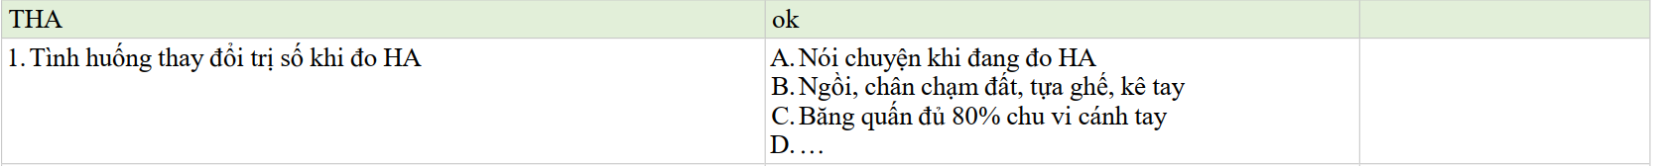

1. Việc nào có thể làm sai lệch kết quả đo huyết áp: nói chuyện khi đo Text, letter

   Description automatically generated Graphical user interface, text, application

   Description automatically generated

Câu 2: *Đề này review chỉ có 3 đề nhớ đc nên chỉ cắt ra 3 câu tương ứng*

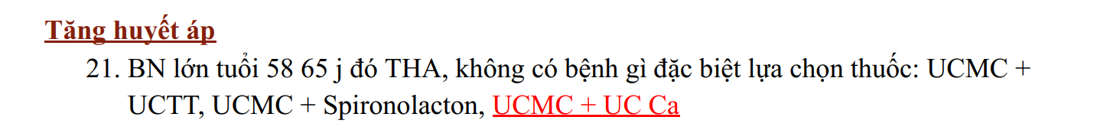

Câu 4

Câu 5

Câu 6

# Vành mạn

Câu 1



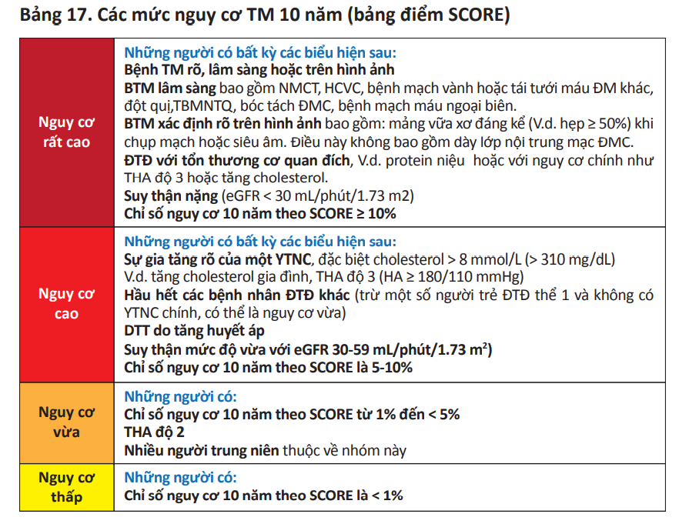

Câu 2



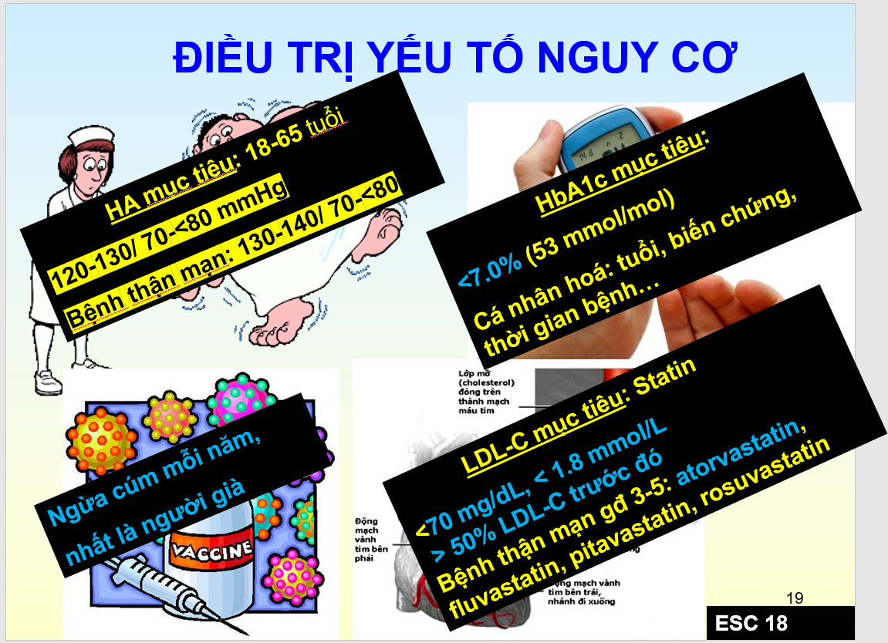



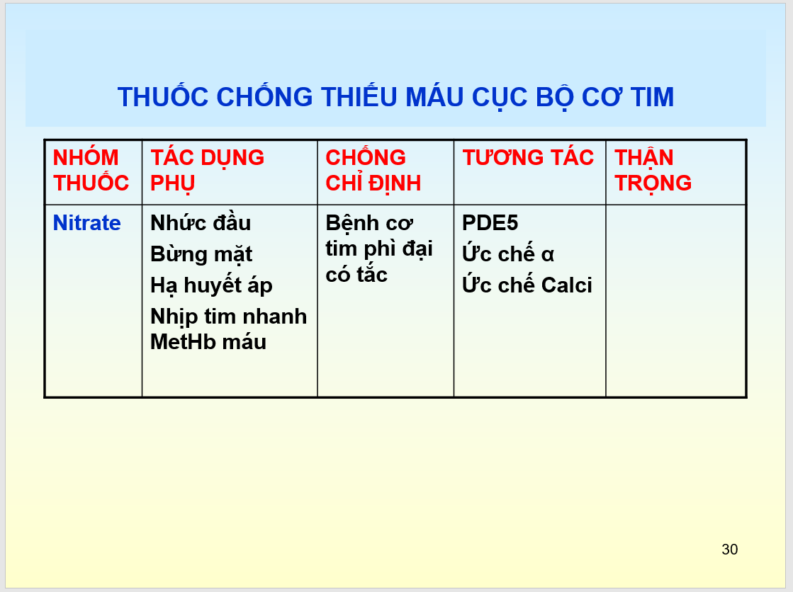 



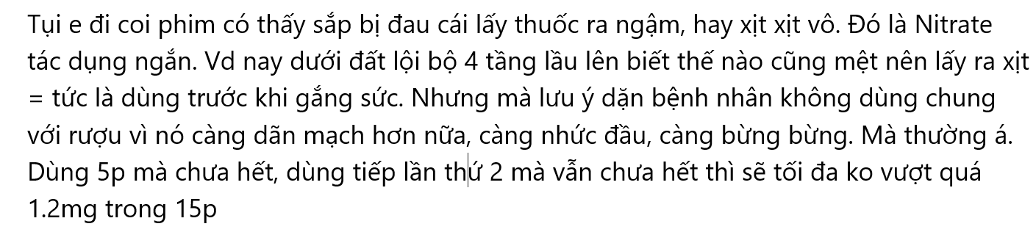



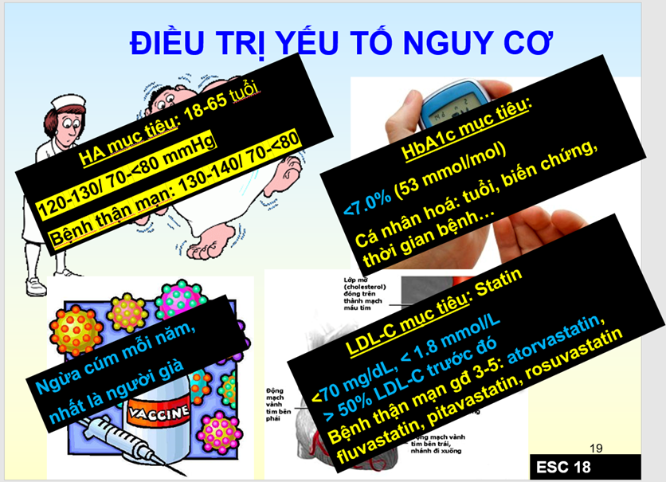

Câu 5



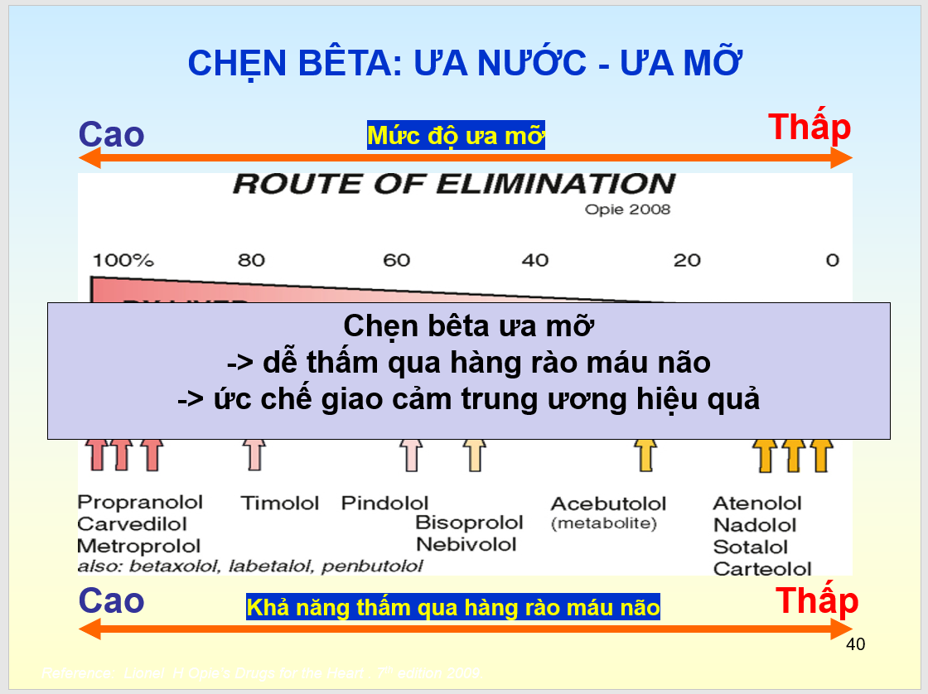

Câu 6



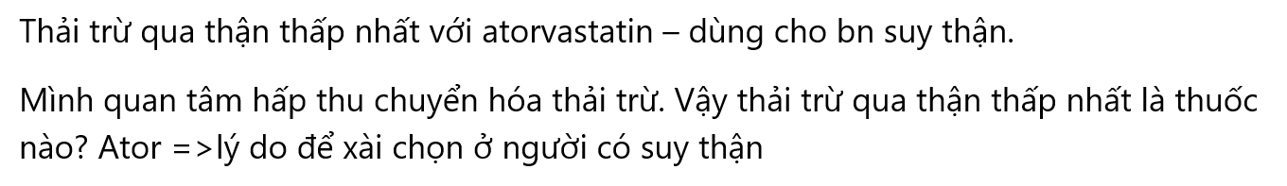

Câu 7



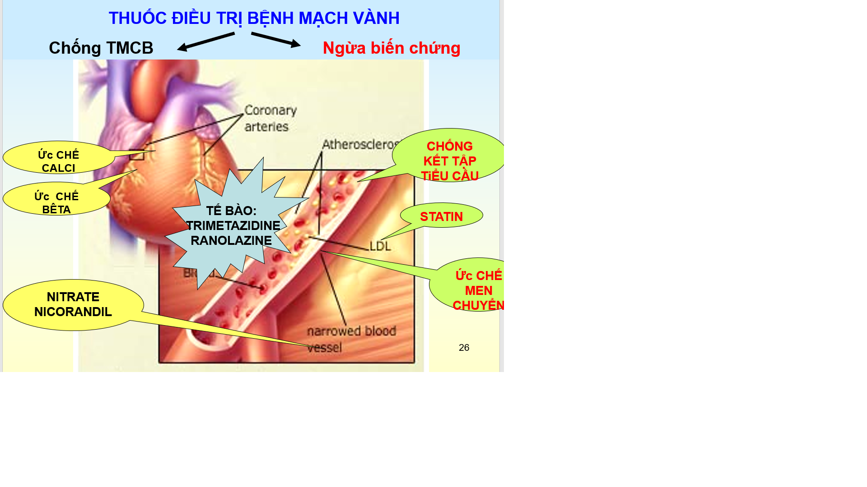



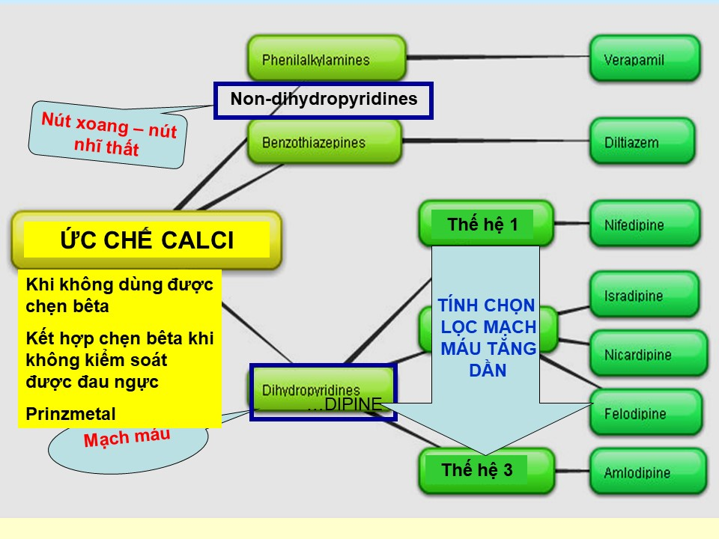

Câu 9:



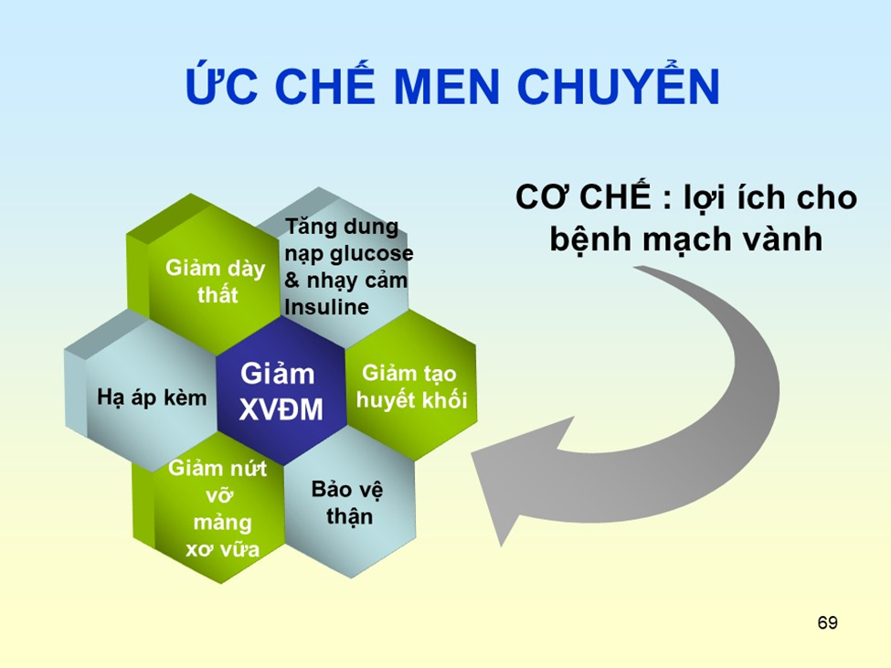

# Suy tim

Câu 1

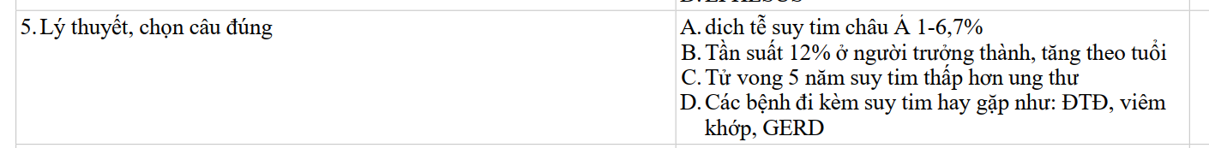

Câu 2

Câu 3

Câu 4

